**Product Design**

| Team | Team 9  Gustavo, Jack, Bader, Linh, Sinikiwe |
| --- | --- |

**Revision**

| *Revision Number* | *Revision Date* | *Summary of Changes* | *Author(s)* |
| --- | --- | --- | --- |
| 0.1 | 10/06/2022 | Updating product design doc to be caught up to today  Design ER Diagram, Class Diagrams, UI designs | Team 9 |
|  |  |  |  |
|  |  |  |  |

# Class Diagram(s)

This is for a UML class diagram capturing the relationships between classes. It is only necessary to show methods that are publicly accessible by other classes. Only show an instance variable of a class if it is publically accessible

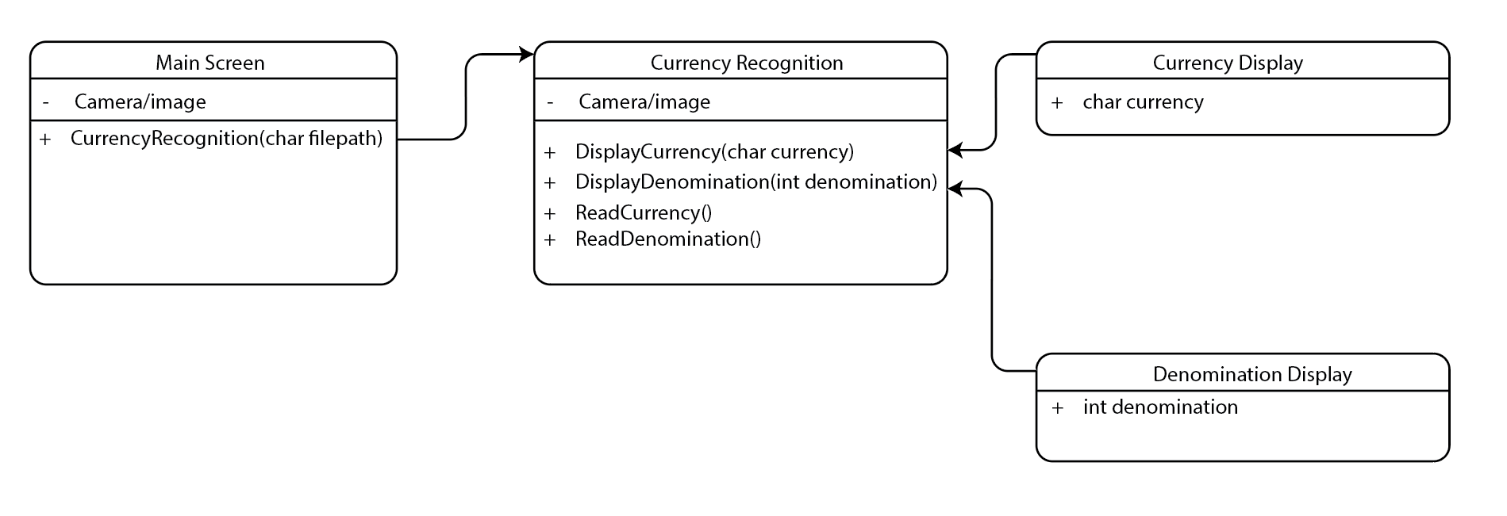

The UML class diagram will be revised as we develop the framework more completely.

# ER Diagram(s)

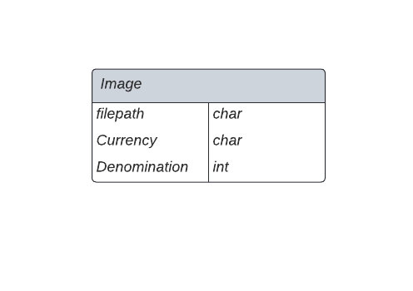

# Information Architecture Diagram

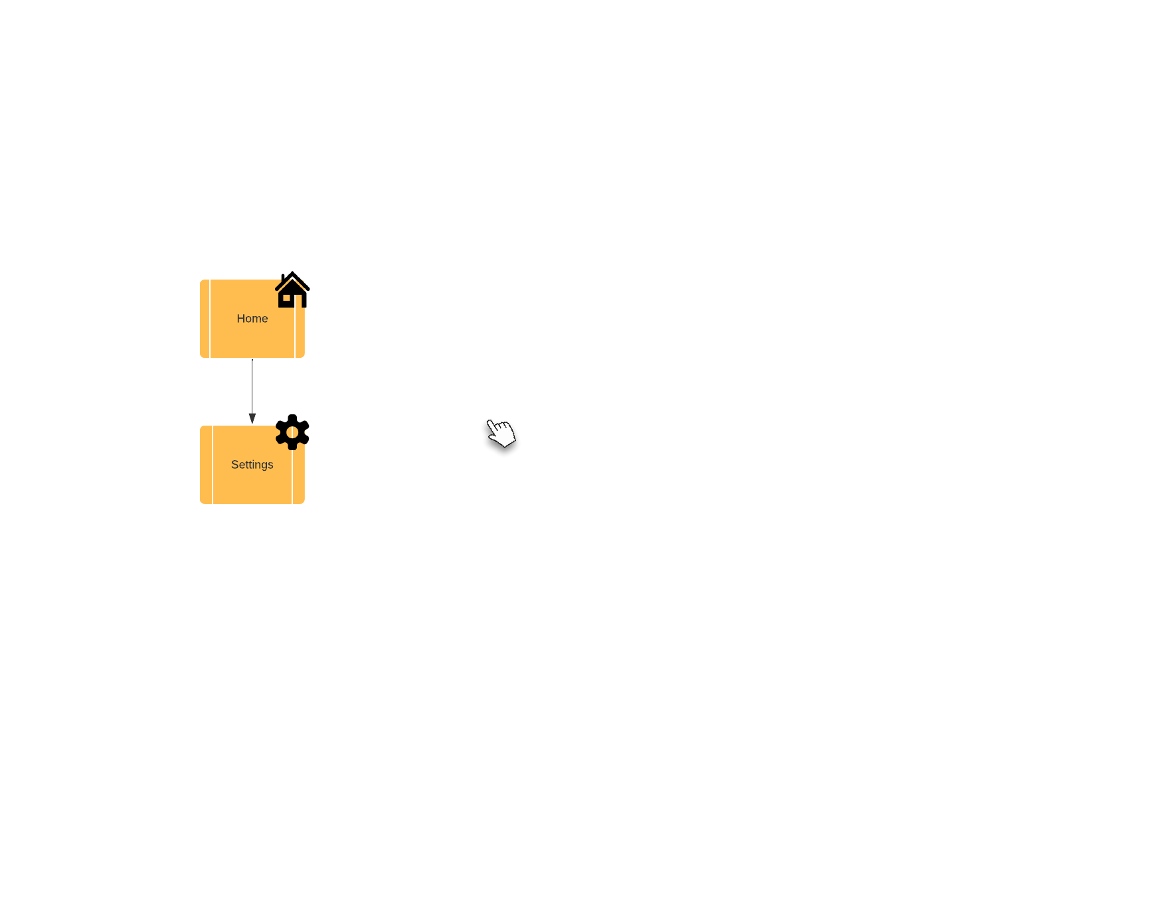

# User Interface Wireframe(s)/Screenshot(s)

These are meant to show the appearance and structure of your key screens. If you are developing an app, present these to the scale of the typical phone that you are designing for. Also provide unique screenID’s, captions and annotations that elaborate on your screens.

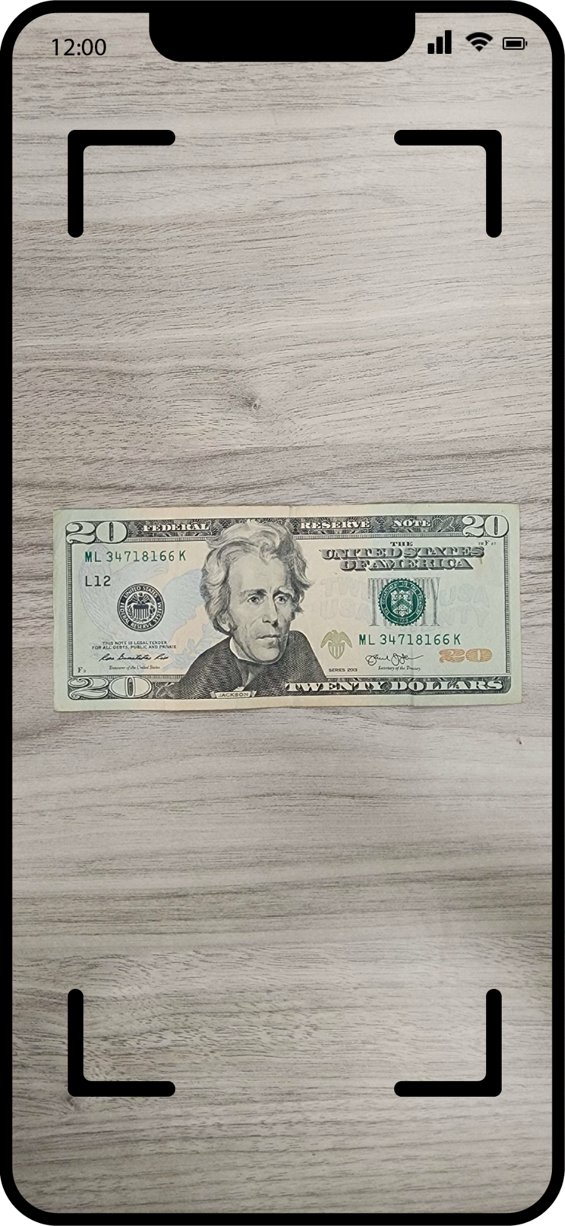

Main Screen: ID = 0

The app opens directly into a camera, meant to be used with Siri and other accessibility features built into iOS. It should be able to be opened through a voice command.

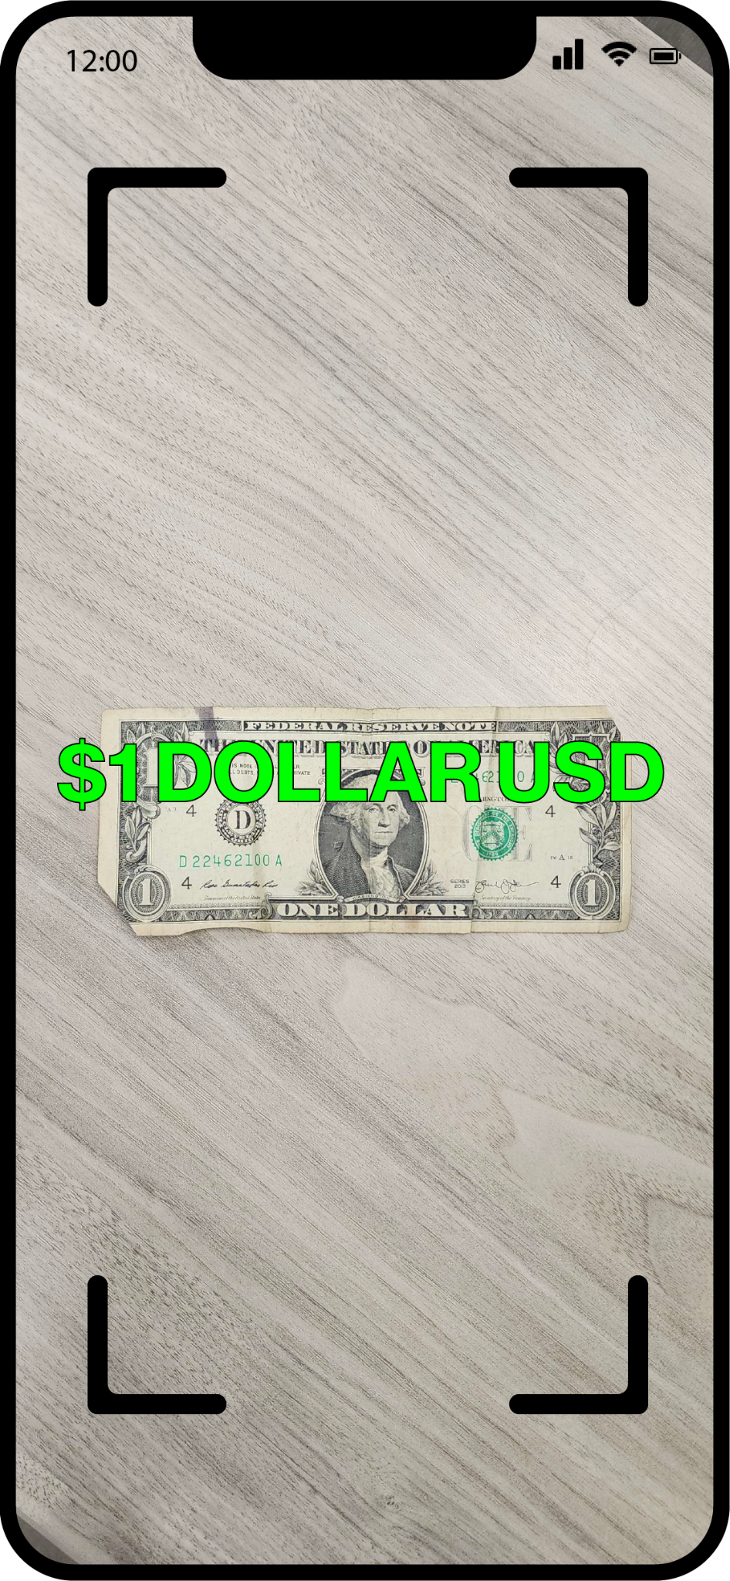

Denomination Screen: ID = 1

The main app screen is very barebones as it is meant to be tied in directly with Siri as well as accessibility features such as screen readers. The text will change based on the denomination of the currency that is being read in through the camera.

# Design Summary

The app is designed for usability therefore it will have only two main screens and collect no data. The only data stored in the app will be compressed examples of training images.

# Design Rationale

Based off of the User interface designs above, the team felt the need to go for a minimalistic and simple view that makes the app easy to navigate. As we established before, this app’s primary function is to count money for blind people. The thought process for us was to make the app as simple as possible, but also accommodating for the struggles that blind people face when interacting with apps. Of the accommodations we pondered over, we felt as if starting the application directly on the camera is a step in the right direction as it pushes the application’s purpose to the front; all someone has to do is place the money in front of the phone after opening the app. Obviously, another question that arose from this idea is, How are blind people expected to open this app? The answer therein lies in the voice assistant; the ideal target for this app is that one can call upon Siri/Google to open the application, and then use voice commands within the app to operate it. The app itself will have basic features such as setting a main currency for the user. At the moment, the plan was to only count denominations of U.S currency; however, the plan is to incorporate other currencies to make the app more practical on a global scale.

One Alternative idea that we considered after observing another money counter app is haptic feedback. Haptic feedback is technology that creates an experience of touch by applying a force or vibrations to the user, which could have a purpose in the app such as counting the money and letting the user know what it is based off the vibrations, which would allow the app to be utilized without the voice commands built in. However, whether or not we implement this feature remains to be seen, as having a functional, efficient voice command system would be a better solution.

As for the act of actually counting the money, the general idea is that we would use an A.I recognition algorithm to match currency images from a database to the currency that the user shows on their camera. The hope for this project is that the A.I will be accurate enough to recognize multiple bills and count them accordingly, but the scope of this goal is limited to a single bill for functionality purposes.

The tradeoffs to the designs we initially proposed is that it does not leave much room for improvement. The purpose of the app is simple in and of itself, but short of adding new currencies, improving response times within the app, or the slight improvement of accuracy in the a.i, the app itself has a ceiling to its overall functionality; but it does ultimately cater to our intended audience.

At this stage, nothing is entirely finalized, but we believe the ideas we have at the moment are the essential forefront for the project. It is very likely that we may introduce more functionality for the app, but as of now, the design rationale should be clear.